1. Project
Title: SISAL (Speleothem Isotopes Synthesis and AnaLysis Working Group) database
Dates: 2017-2019
Funding organisations: Past Global Changes (PAGES) programme, European Research Council (ERC 694481_GC2.0), JPI-Belmont through the UK Natural Environmental Research Council (NE/P006752/1), Geological Survey Ireland Short Call 2017 (2017-SC-056), University College Dublin Seed Funding award (SF1428), European Geosciences Union (W2017/413), University of Reading, Irish Centre for Research in Applied Geosciences (iCRAG), European Association of Geochemistry (Early Career Ambassadors program 2017), Geological Survey Ireland, the Quaternary Research Association UK, Navarino Environmental Observatory, Stockholm University, Savillex, John Cantle, University of Ibn Zhor.
Grant number: ERC 694481_GC2.0, NE/P006752/1, 2017-SC-056, SF1428, W2017/413
2. Dataset
Title: SISAL (Speleothem Isotopes Synthesis and AnaLysis Working Group) database version 1b
Summary description. Stable isotope records from speleothems provide information on past climate changes, most particularly information that can be used to reconstruct past changes in precipitation and atmospheric circulation. SISAL (Speleothem Isotope Synthesis and Analysis) is an international working group of the Past Global Changes (PAGES) project. The working group aims to provide a comprehensive compilation of speleothem isotope records for climate reconstruction and model evaluation. Version 1b of the SISAL database contains oxygen and carbon isotope measurements from 440 individual and 15 composite speleothem records from 221 cave systems worldwide, as well as metadata describing their cave settings and age-depth models. New records have been added and some metadata has been amended. The SISAL working group has also created SISAL chronologies for 20 entities, all of which had no published chronologies.
Publication year: 2019
Creators: Kamolphat Atsawawaranunt, Sandy P. Harrison, Laia Comas-Bru
Organisation: Geography and Environmental Science, University of Reading, UK and School of Earth Sciences, University College Dublin, Belfield, Dublin 4, Ireland
Rights Holder: University of Reading, University College Dublin
University College Dublin is a joint holder with the University of Reading of copyright in version 1 of the SISAL database (Atsawawaranunt et al., 2018a) which has been incorporated into the present version. All changes made to produce version 1b of the SISAL database (Atsawawaranunt et al., 2019) as here presented were undertaken at the University of Reading and are the sole copyright of the University of Reading.
3. Terms of use
This dataset is licensed by the rights-holder(s) under a Creative Commons Attribution 4.0 International Licence: https://creativecommons.org/licenses/by/4.0/.
In order to assure traceability, any presentation, report, or publication that uses the SISALv1b database should cite Atsawawaranunt et al. (2018b) and Comas-Bru et al. (2019). If using individual sites, the literature citations for published work provided in the database should also be cited. Contact information of data contributors of unpublished data is also provided and these should be contacted when unpublished records are used on an individual basis.

4. Contents
Abstract: Stable isotope records from speleothems provide information that can be used to reconstruct past changes in precipitation and atmospheric circulation. These records are increasingly being used to provide “out-of-sample” evaluations of isotope-enabled climate models. SISAL (Speleothem Isotope Synthesis and Analysis) is an international working group of the Past Global Changes (PAGES) project (http://pastglobalchanges.org/ini/wg/sisal). The working group aims to provide a comprehensive compilation of speleothem isotope records for climate reconstruction and model evaluation. The SISAL database contains data for individual speleothems, grouped by cave system. Stable isotopes of oxygen and carbon (δ¹⁸O, δ¹³C) measurements are referenced by distance from the top or the bottom of the speleothem. Additional tables provide information on dating, including information on the dates used to construct the original age-depth model and sufficient information to assess the quality of each data set and to create new chronologies. The metadata tables provide location information, information about the full range of measurements carried out on each speleothem and information about the cave system that is relevant to the interpretation of the records, as well as citations for both publications and archived data.
There is a single MySQL database file (sisalv1b.sql). Please check https://dev.mysql.com/downloads/ to download and install MySQL. Once MySQL Community Server and MySQL Workbench are installed, the database can be imported and visualised. A schema must be created upon import. To import the SQL file, you follow:
- Open MySQL Workbench
- Connect to the connection you would like to store your database in. A connection is usually created during the installation process (usually root@localhost with the password defined during the installation process)
- Server>Data Import>Import from Self-contained file
- Browse to the SQL file you have downloaded
- Press New… next to the Default Target Schema to create a new schema (name this as appropriate, such as sisalv1b)
- Press Import
Note that once the database is imported, there are packages and modules in several programming languages which will allow you to connect to the database such as RMySQL in R, and MySQLdb in Python. Example scripts of how this is done in R and Python can be found in sisalv1b_codes.zip (details below).
There is a single compressed archive file (sisalvb.zip) comprising 15 CSV files that correspond to the 15 individual tables in the MySQL database. The names of the CSV files correspond to the names used in the database tables (see Figure 1). CSV files do not contain defined relationships but the tables can be joined in different programming languages (R, Python, etc.) based on the foreign keys (shared column names between tables such as site_id in the site and entity tables). These relationships are described in Figure 1 and the characteristics of each table are described in Tables 1 – 15. Please note that CSV files are in UTF-8 characters, and special characters (such as Greek characters and letters with accents in contact names and citations) may not be reproduced correctly when open as default in Excel. Please see https://scrapehero.freshdesk.com/support/solutions/articles/5000617795-how-to-open-csv-files-that-have-unicode-unprintable-or-weird-looking-characters-in-excel for instructions on how to open this in Excel.
There is a single compressed archive file (sisalv1b_codes.zip) comprising examples of codes and queries that can be used with the MySQL database (sisalv1b_connect2db.py and sisalv1b_connect2db.R), but also with the CSV files (sisalv1b_csv_db.R). Within this compressed archive file, there is:
- An html file (sisalv1b_intro_example.html) which shows example SQL queries on the database
- A python file (sisalv1b_connect2db.py) demonstrating how to connect python to the database once the database has been uploaded into MySQL.
- An R file (sisalv1b_connect2db.R) demonstrating how to connect R to the database once the database has been uploaded into MySQL.
- An R file (sisalv1b_csv_db.R) demonstrating how to load the CSV files into R and query these CSV files without the need to install MySQL.
Please note that there may be some authentication issues when using MySQL 8.0, especially when trying to connect from R/Python. This could be due to the change in the default authentication plugin from mysql_native_password to caching_sha2_password. One way around this is to run the following MySQL query in MySQL Workbench:
ALTER USER 'username’@‘host’ IDENTIFIED WITH mysql_native_password BY ‘password’;
where ‘username’ refers to the user’s username ( ‘root’ if MySQL is run locally), ‘host’ refers to the host name ( ‘localhost’ if MySQL is run locally) and ‘password’ refers to the password (if MySQL is run locally, this is usually the password set up when installing MySQL).
SISAL database version 1b is an updated version of the SISAL database version 1 (Atsawawaranunt et al., 2018a, 2018b). New records have been added, and additional data (such as elevation, rock_age and geology which in some cases were unknown) have also been added to records already in v1. Moreover, some records have been amended where mistakes were found.
The SISAL working group has created new linear or COPRA-based (Breitenbach et al., 2012) age-depth models for 20 entities for which age-depth models were not available in their original publications. These have been added to a new table (sisal_chronology). Information on which dates were used to produce these new age-depth models can be found in the two new columns of the dating table: date_used_COPRA and date_used_linear.
For details on what has been added or amended to the SISAL database version 1 to produce version 1b, see document named ‘sisalv1b_updates_since_sisalv1.pdf’.

5. References
Atsawawaranunt, K., Harrison, S., Comas-Bru, L.: SISAL (Speleothem Isotopes Synthesis and AnaLysis Working Group) database Version 1.0. University of Reading. Dataset. http://dx.doi.org/10.17864/1947.147, 2018a.
Atsawawaranunt, K., Comas-Bru, L., Amirnezhad Mozhdehi, S., Deininger, M., Harrison, S. P., Baker, A., Boyd, M., Kaushal, N., Ahmad, S. M., Ait Brahim, Y., Arienzo, M., Bajo, P., Braun, K., Burstyn, Y., Chawchai, S., Duan, W., Hatvani, I. G., Hu, J., Kern, Z., Labuhn, I., Lachniet, M., Lechleitner, F. A., Lorrey, A., Pérez-Mejías, C., Pickering, R., Scroxton, N. and SISAL Working Group Members: The SISAL database: a global resource to document oxygen and carbon isotope records from speleothems, Earth Syst. Sci. Data, 10(3), 1687–1713, https://doi.org/10.5194/essd-10-1687-2018, 2018b.
Atsawawaranunt, K., Harrison, S., Comas-Bru, L.: SISAL (Speleothem Isotopes Synthesis and AnaLysis Working Group) database Version 1b. University of Reading. Dataset. http://dx.doi.org/10.17864/1947.189, 2019.
Breitenbach, S. F. M., Rehfeld, K., Goswami, B., Baldini, J. U. L., Ridley, H. E., Kennett, D. J., Prufer, K. M., Aquino, V. V., Asmerom, Y., Polyak, V. J., Cheng, H., Kurths, J. and Marwan, N.: Constructing proxy records from age models (COPRA), Clim. Past, 8(5), 1765–1779, https://doi.org/10.5194/cp-8-1765-2012, 2012.
Comas-Bru, L., Harrison, S.P., Werner, M., Rehfeld, K., Scroxton, N., Vega-Pires, C., and SISAL Working Group Members: Using speleothem records of climate changes since the last glacial for model evaluation, Climate of the Past (submitted).

File structure: The data is stored in a relational database (MySQL), which consists of 15 linked tables. Specifically: site, entity, sample, dating, dating_lamina, gap, hiatus, original_chronology, sisal_chronology, d13C, d18O, entity_link_reference, reference, composite_link_entity. Figure 1 shows the relationships between these tables. The structure and contents of each table is described below.
Figure 1: The structure of the SISAL database, showing individual tables (and their contents) and the nature of the relationships between them. “Many to one linkages” (dashed grey arrows) indicate that it is possible to have several entries in one table linked to a single entry in another table.

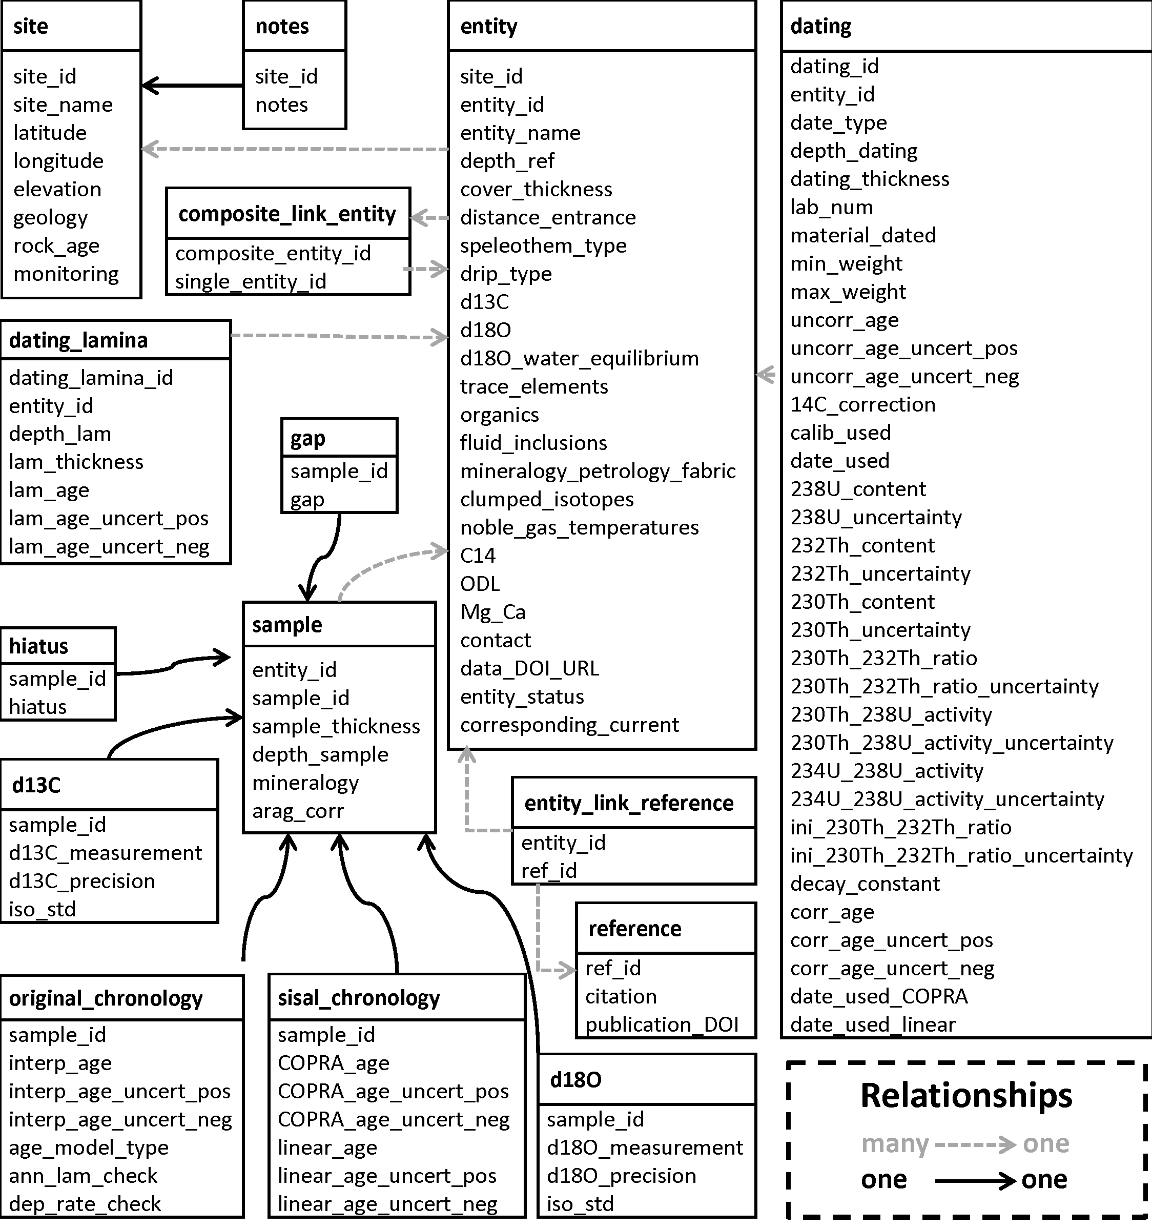
Table 1: Characteristics of the site table (site)

Field label | Definition | Format | Constraints
site_id | Unique identifier for each site, where a site is defined as a cave or cave system | Numeric | Positive integer
site_name | Site name as given by original authors or as defined by us where there was no unique name given to the site | Text | None
latitude | Latitude of the cave site, given in decimal degrees, where N is positive and S is negative | Numeric | None
longitude | Longitude of the cave site, given in decimal degrees, E is positive and W is negative | Numeric | None
elevation | Elevation of the cave, in meters above sea level (where negative values indicate elevations below sea level) | Numeric | None
geology | Description of the rock type | Text | selected from pre-defined list
rock_age | Description of age of the rock | Text | selected from pre-defined list
monitoring | Indication of whether cave monitoring has been carried out for more than one season | Text | selected from pre-defined list

Table 2: Characteristics of the entity table (entity)

Field | Definition | Format | Constraints
site_id | Refers to the unique identifier for each site (as given in site table) | Numeric | Positive integer
entity_id | Unique identifier for each entity, where an entity is defined as a speleothem or a speleothem composite | Numeric | Positive integer
entity_name | Speleothem name | Text | None
entity_status | Information of whether the entity has been partially or completely superseded. | Text | selected from pre-defined list
corresponding_current | This refers to the entity_id of the record replacing a completely or partially superseded record. | Numeric | Positive integer
depth_ref | Indication of whether the reference point is the top or base of the speleothem | Text | selected from pre-defined list
cover_thickness | Thickness of overlying bedrock above the speleothem (m) | Numeric | Positive decimal
distance_entrance | Distance of the speleothem from the cave entrance (m) | Numeric | Positive decimal
speleothem_type | Description of the speleothem type | Text | selected from pre-defined list
drip_type | Description of the drip type | Text | selected from pre-defined list
d13C | Indication of whether δ¹³C measurements have been made | Text | selected from pre-defined list
d18O | Indication of whether δ¹⁸O measurements have been made | Text | selected from pre-defined list
d18O_water_equilibrium | Indication of whether studies assessing if the speleothem is precipitating in equilibrium with their dripwaters have been done | Text | selected from pre-defined list
trace_elements | Indication of whether trace elements have been measured | Text | selected from pre-defined list
organics | Indication of whether organics have been measured | Text | selected from pre-defined list
fluid_inclusions | Indication of whether fluid inclusions have been measured | Text | selected from pre-defined list
mineralogy_petrology_fabric | Indication of whether fabric studies have been made | Text | selected from pre-defined list
clumped_isotopes | Indication of whether clumped isotopes have been measured | Text | selected from pre-defined list
noble_gas_temperatures | Indication of whether noble gases have been measured | Text | selected from pre-defined list
C14 | Indication of whether ¹⁴C measurements have been made | Text | selected from pre-defined list
ODL | Indication of whether optical density of luminosity measurements have been made | Text | selected from pre-defined list
Mg_Ca | Indication of whether the Mg/Ca ratio measurements have been made | Text | selected from pre-defined list
contact | Name of the person who entered the data into the workbook | Text | None
data_DOI_URL | Digital Object Identifier (DOI) of the data or URL of the webpage from which the data can be obtained. | Text | None

Table 3: Characteristics of the sample table (sample)

Field | Description | Format | Constraints
entity_id | Refers to the unique identifier for each entity (as given in entity table) | Numeric | Positive integer
sample_id | Unique identifier for the sample | Numeric | Positive integer
sample_thickness | Thickness of the sample analysed (mm) | Numeric | Positive decimal
depth_sample | Distance in mm from a reference point | Numeric | Positive decimal
mineralogy | Description of the mineralogy of the sample | Text | selected from pre-defined list
arag_corr | Indication of whether aragonite isotope measurements have been corrected to their calcite equivalent | Text | selected from pre-defined list

Table 4: Characteristics of the dating information table (dating)

Field | Description | Format | Constraints
dating_id | Unique identifier for each date | Numeric | Positive integer
entity_id | Refers to the unique identifier for each entity (as given in entity table) | Numeric | Positive integer
date_type | Description of the dating method used | Text | selected from pre-defined list
depth_dating | Distance in mm from a reference point | Numeric | Positive decimal
dating_thickness | Thickness of dated sample in mm | Numeric | Positive decimal
lab_num | The laboratory number of the dated sample | Text | None
material_dated | Mineralogy of the dated sample | Text | selected from pre-defined list
min_weight | Minimum weight of the dated sample in mg | Numeric | Positive decimal
max_weight | Maximum weight of the dated sample in mg | Numeric | Positive decimal
uncorr_age | Uncorrected age of the dated sample in years | Numeric | None
uncorr_age_uncert_pos | Positive uncertainty of the uncorrected age of the dated sample in years | Numeric | Positive decimal
uncorr_age_uncert_neg | Negative uncertainty of the uncorrected age of the dated sample in years | Numeric | Positive decimal
14C_correction | Percentage of estimated dead carbon content in dated sample | Numeric | Positive decimal
calib_used | Calibration method used to convert C¹⁴ dates to calendar years | Text | selected from pre-defined list
date_used | Indication of whether the date is used in the original age model | Text | selected from pre-defined list
238U_content | ²³⁸U content of the dated sample in ppb | Numeric | None
238U_uncertainty | ²³⁸U 2-sigma uncertainty of dated sample in ppb | Numeric | None
232Th_content | ²³²Th content of the dated sample in ppt | Numeric | None
232Th_uncertainty | ²³²Th 2-sigma uncertainty of the dated sample in ppt | Numeric | None
230Th_content | ²³⁰Th content of the dated sample in ppt | Numeric | None
230Th_uncertainty | ²³⁰Th 2-sigma uncertainty of the dated sample in ppt | Numeric | None
230Th_232Th_ratio | ²³⁰Th/²³²Th activity ratio of the dated sample | Numeric | None
230Th_232Th_ratio_uncertainty | ²³⁰Th/²³²Th activity ratio 2-sigma uncertainty of the dated sample | Numeric | None
230Th_238U_activity | ²³⁰Th/²³⁸U activity ratio of the dated sample | Numeric | None
230Th_238U_activity_uncertainty | ²³⁰Th/²³⁸U activity ratio 2-sigma uncertainty of the dated sample | Numeric | None
234U_238U_activity | ²³⁴U/²³⁸U activity ratio of the dated sample | Numeric | None
234U_238U_activity_uncertainty | ²³⁴U/²³⁸U activity ratio 2-sigma uncertainty of the dated sample | Numeric | None
ini_230Th_232Th_ratio | Initial ²³⁰Th/²³²Th activity ratio for the detrital correction | Numeric | None
ini_230Th_232Th_ratio_uncertainty | Initial ²³⁰Th/²³²Th activity ratio uncertainty for the detrital correction | Numeric | None
decay_constant | The reference of of the half-life used for ²³⁰Th and ²³⁴U for U/Th samples | Text | selected from pre-defined list
corr_age | Corrected age of the dated sample in years before 1950 CE | Numeric | None
corr_age_uncert_pos | Positive uncertainty of corrected age of the dated sample in years | Numeric | Positive decimal
corr_age_uncert_neg | Negative uncertainty of corrected age of the dated sample in years | Numeric | Positive decimal
date_used_COPRA | Indication of whether the date was used in the construction of COPRA_age and its uncertainties as in the sisal_chronology table | Text | selected from pre-defined list
date_used_linear | Indication of whether the date was used in the construction of linear_age and its uncertainties as in the sisal_chronology table | Text | selected from pre-defined list

Table 5: Characteristics of the lamina dating information table (dating_lamina)

Field | Description | Format | Constraints
dating_lamina_id | Unique identifier for each lamina | Numeric | Positive integer
entity_id | Refers to the unique identifier for each entity (as given in entity table) | Numeric | Positive integer
depth_lam | Depth of the midpoint of the lamina in mm from a reference point (as defined in the entity metadata table) | Numeric | Positive integer
lam_thickness | Thickness in mm of the sample dated | Numeric | Positive decimal
lam_age | Age in years before 1950 CE of individual lamina | Numeric | None
lam_age_uncert_pos | Positive uncertainty of individual lamina in years | Numeric | Positive decimal
lam_age_uncert_neg | Negative uncertainty of individual lamina in years | Numeric | Positive decimal

Table 6: Characteristics of the hiatus place mark information table (hiatus)

Field | Description | Format | Constraints
sample_id | Refers to the unique identifier for each sample (as given in sample table) | Numeric | Positive integer
hiatus | Indication of the presence of a growth hiatus | Text | selected from pre-defined list

Table 7: Characteristics of the gap place mark information table (gap)

Field | Description | Format | Constraints
sample_id | Refers to the unique identifier for the sample (as given in sample table) | Numeric | Positive integer
gap | Indication of the presence of a temporal gap in a composite record | Text | selected from pre-defined list

Table 8: Characteristics of the original chronology information table (original_chronology)

Field | Description | Format | Constraints
sample_id | Refers to the unique identifier for the sample (as given in sample table) | Numeric | Positive integer
interp_age | Age of the sample in years before 1950 CE | Numeric | Positive decimal
interp_age_uncert_pos | Positive uncertainty of the age of the sample in years | Numeric | None
interp_age_uncert_neg | Negative uncertainty of the age of the sample in years | Numeric | Positive decimal
age_model_type | Description of the age-depth model used in the original publication | Text | selected from pre-defined list
ann_lam_check | Indication of the method used to verify that laminae are annual, in cases when lamina counting is used to construct the age-depth model | Text | selected from pre-defined list
dep_rate_check | Indication whether verification of the deposition rate has been made | Text | selected from pre-defined list

Table 9: Characteristics of the carbon isotope data table (d13C)

Field | Description | Format | Constraints
sample_id | Refers to the unique identifier for the sample (as given in sample table) | Numeric | Positive integer
d13C_measurement | Raw δ¹³C measurement in permil | Numeric | None
d13C_precision | Laboratory precision on the δ¹³C measurement in permil | Numeric | None
iso_std | Description of isotopic standard used | Text | selected from pre-defined list

Table 10: Characteristics of the oxygen isotope data table (d18O)

Field | Description | Format | Constraints
sample_id | Refers to the unique identifier for the sample (as given in sample table) | Numeric | Positive integer
d18O_measurement | Raw δ¹⁸O measurement in permil | Numeric | None
d18O_precision | Laboratory precision on the δ¹⁸O measurement in permil | Numeric | None
iso_std | Description of isotopic standard used | Text | selected from pre-defined list

Table 11: Characteristics of the publication information table (reference)

Field | Description | Format | Constraints
ref_id | Unique identifier for the reference | Numeric | Positive integer
citation | Full citation for the original publication | Text | None
publication_DOI | Digital Object Identifier (DOI) of publication | Text | None

Table 12: Characteristics of the link entity and publication information table (entity_link_reference)

Field | Description | Format | Constraints
entity_id | Refers to the unique identifier for the entity (as given in entity table) | Numeric | Positive integer
ref_id | Refers to the unique identifier for the publication (as given in the publication information table) | Numeric | Positive integer

Table 13: Characteristics of the link composite and entity table (composite_link_entity)

Field | Description | Format | Constraints
composite_entity_id | Refers to the unique identifier for a composite entity (as given in entity table) | Numeric | Positive integer
single_entity_id | Refers to the unique identifier for each single entity in the composite (as given in entity table) | Numeric | Positive integer

Table 14: Characteristics of the notes table (notes)

Field | Description | Format | Constraints
site_id | Refers to the unique identifier for each site (as given in site table) | Numeric | Positive integer
notes | Notes and additional information about the site (including information on its entities, dates and/or age-depth models) | Text | None

Table 15: Characteristics of the sisal chronology information table (sisal_chronology)

Field | Description | Format | Constraints
sample_id | Refers to the unique identifier for the sample (as given in sample table) | Numeric | Positive integer
COPRA_age | Age of the sample in years before 1950 CE, based on the COPRA age-depth model | Numeric | None
COPRA_age_uncert_pos | Positive uncertainty of COPRA_age in years | Numeric | Positive decimal
COPRA_age_uncert_neg | Negative uncertainty of COPRA_age in years | Numeric | Positive decimal
linear_age | Age of the sample in years before 1950 CE, based on the linear age-depth model | Numeric | None
linear_age_uncert_pos | Positive uncertainty of linear_age in years | Numeric | Positive decimal
linear_age_uncert_neg | Negative uncertainty of linear_age in years | Numeric | Positive decimal

